ECONOMIC DEVELOPMENT CORPORATION
Activity Report: Month Ending November 2023

ECONOMIC DEVELOPMENT REVOLVING LOAN FUND (EDRLF)
- Total Balance to Loan $89,588 Accounts Receivable: $497,139 Amount Leveraged: $3.356 Million
Economic Development Information:
Implementation Efforts from the Strategic Summit: Continuation
- Working with potential WEDC Community Development Investment Grant applicants with multiple businesses
- Continue to review empty buildings/land with owners, real estate professionals, and potential uses in Langlade County
- Marketed empty buildings on Locate In Wisconsin and potential developers and interested buyers
Business Development/Retention and Expansion Activities
- Eight (8) New Business Inquires/Mtgs
- Four (4) Existing Business Visits/Mtgs
- Closed on one (1) Revolving Loan Fund loan
- Worked with one entrepreneur in obtaining a WWBIC loan for purchase of existing businesses. Loan closing is in December
- Toured Wausau business for potential expansion in Antigo
Workforce Development
- Dream Up Childcare Taskforce meetings were held. Grant Guidelines and Application established. Child Care Resource Fair was held at the Antigo Public Library on November 15. Survey was created and Marketing Strategy are being implemented. Reports submitted
- Langlade County Human Resource meeting was held to share best practices and needs
- Continuing to work with Inspire Grow North, Regional Economic Development on Talent Cultivation: New Liaison for Antigo School District
- Moderated the Antigo High School Career Day panel
Entrepreneurship
- Submitted WEDC Partners Grant for Entrepreneurial Hub
- Working with Navigator Grant to enhance Entrepreneurship Trainings and Partnerships
- Working with NTC, WWBIC and SBDC for fall business education courses
- The Fall ETP Class graduated on November 14. Business plans will be presented to the LCED Executive Committee for consideration for an ETP Business Start Up Grant in December.
- Moderated SBDC Women’s Conference in Stevens Point.
Broadband
- Neva Broadband Project submitted
- Mapping in Progress to be prepared for the BEAD Funding
- Updates given at Langlade County Board
- BEAD Planning Grant Reimbursement Report Submitted
- Broadband Committee meets monthly; 3rd Tuesday of Month at 5:00 PM
Meetings/Trainings attended

- SBDC Women’s Conference
- AMS Family Night
- Grow North
- Langlade County Transportation
- ITBEC Marketing
- Antigo City Council
- Destination Wisconsin Fall Conference
- Langlade County Human Resource Group
- Langlade County Administration
- Dream Up/Child Care Task Force
- Workforce Development Board
- City Finance, Personnel, and Legislative Committee
- Building a Healthier Langlade County
- AHS Career Fair
- Langlade County Forestry, Park, & Recreation
- Public Relations Measurement: How to Show Value
- WEDA Board
- Langlade County Board
- City of Antigo Hotel Motel Commission
- ITBEC Board
- Child Care Resource Fair
Tourism Development
- Tourism Website: 4,231 Users in the months of November
Top referral site: Google Ad Clicks
- App Downloads: 6 downloads in December 2023
- Recreation Information Requests: 26 Recreation Requests in November 2023
Top Request: Rec Map & ATV/UTV Map
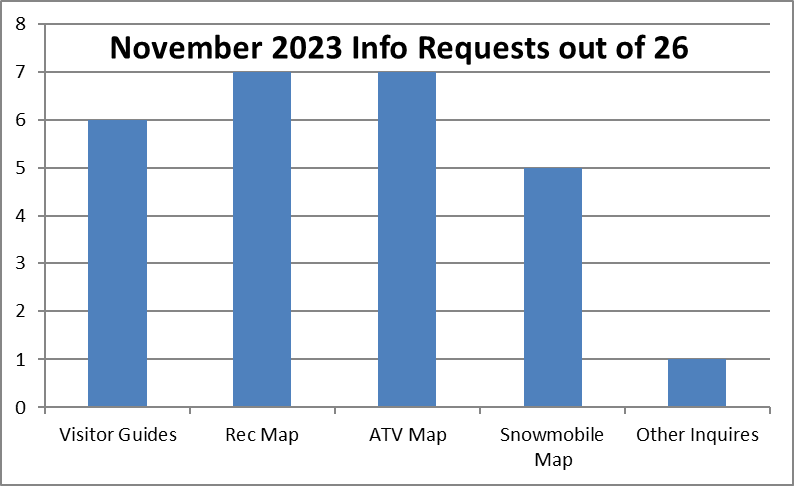
- Distributed: 3,529 of the 2023 Langlade County Visitor Guide have been distributed from the Economic Development Corporation Office since January 23, 2023.
- Facebook: 14,122 “Followers” The top post in November was about ATV/UTV trails close on December 1. This post reached 21,571 people, 173 interactions, 73 shares, and 27 link clicks.
- Instagram: 479 “Followers” as of November 2023.
- Everbridge: There have been 1,392 people that have registered since June 1, 2016.
- Northcentralwisconsin.com: This is the portal website through ITBEC and we received 13 visits to Langlade County Page in the month of November.
- alcinfo.com: 220 users in the month of November:
langladecounty.org: 1 referral langladecountyedc.org: 1 referral
Other Tourism Information:
- Continued sending out Everbridge mass notifications and marketing Everbridge and alcinfo.com webpage.
- Continue refining the Langlade County Tourism Information binder for staff and volunteers for answers to visitor’s questions.
- Continued Social Siren Marketing social and digital marketing campaigns.
- Travel Wisconsin’s Hiking and Biking Report are updating reports for Langlade County on a weekly basis.
- Travel Wisconsin’s Winter Snow Report is live. LCEDC has been updating the 12 reports on a weekly basis.
- Booth at the Antigo Middle School Family Night. In 1.5 hours, 73 items were taken.
- Langlade County Tourism three winter commercials started running on November 1st on WAOW Channel 9.
- ITBEC Marketing Group discussed 2024 additional tourism marketing ideas.
- Attended Destination Wisconsin’s Fall Tourism Conference to learn about trends, apps, and use of AI in tourism.
- Submitted Winter Sports write up to Travel Wisconsin’s public relations to be considered for future promotion/articles.
- Virtually attended Public Relations Measurement: How to Show Value webinar.
- Finished adding Go To Spot information to Langlade County Tourism website.
- Developing the 2024 Langlade County Recreation Map with the City of Antigo, Langlade County, and Regional Planning.

