ECONOMIC DEVELOPMENT CORPORATION
Activity Report: Month Ending July 2023

ECONOMIC DEVELOPMENT REVOLVING LOAN FUND (EDRLF)
- Total Balance Available to Loan $125,431
EDC Activities Report
- Economic Development Corporation Business Website: 283 Users in the month of June.
Top referral sites: Facebook
- Facebook: 1,447 “Followers” The top post in July was the announcement that Mosaic Massage and Float Center is now open. This post reached 1,799 people with 470 engagements.
- Instagram: Langlade County EDC on Instagram launched on April 10, 2022. There are 79 “Followers” as of July 2023.
Economic Development Information:
Implementation Efforts from the Strategic Summit: Continuation
- Reviewing empty buildings with owners, real estate professionals, and potential uses in Langlade County
- Marketed empty buildings on Locate In Wisconsin and potential developers and interested buyers
- Roundtable discussion with WEDC on new programs for enhancements of buildings

Business Development/Retention and Expansion Activities
- Six (6) New Business Inquires/Mtgs
- Two (2) Existing Business Visits/Mtgs
- Working with three (3) applicants for Gap Financing from the Revolving Loan Fund
- Langlade County Microbusiness Grant Closed Out
- Submitted EDA Reports as Requested for Industrial Project.
- Continue to provide information to Sartori Leaders and Investors to secure New Market Tax Credit

Workforce Development
- Dream Up Childcare Taskforce meeting was held
- Langlade County HR Group met and shared information and best practices; This group meets quarterly
- Continuing to work Inspire Grow North, Regional Economic Development on Talent Cultivation; New Talent Cultivation hired at CEASA 8 to help

Entrepreneurship
- Working with Navigator Grant to enhance Entrepreneurship Trainings and Partnerships
- Working with NTC, WWBIC and SBDC for fall business education courses
- 2023 Fall ETP Schedule Determined

Broadband
- Mapping in Progress
- Updates given at Langlade County Board
- New Grant Funding announced and working on possible project to submit
- Broadband Committee meets monthly; 3 Tuesday of Month @ 5:00 PM

Meetings/Trainings attended

- Langlade County Forestry Committee
- USDA Webinar
- Wisconsin Economic Development Corporation Strategic Round Table
- WEDA Board
- Building a Healthier Langlade County
- Grow North Board
- Library Solar Project
- Langlade County Strategic Planning
- Langlade County Administration
- North Central Regional Planning Board
- CWED Board
- Dream Up/Child Care Task Force
- Town of Summit Broadband
- Langlade County Board Mtg
- Langlade County HR Taskforce
Tourism Development
- Tourism Website: 9,280 Users in the months of July
Top referral site: Facebook
- App Downloads: 11 downloads in July 2023
- Recreation Information Requests: 72 Recreation Requests in July 2023
Top Request: Visitor Guides
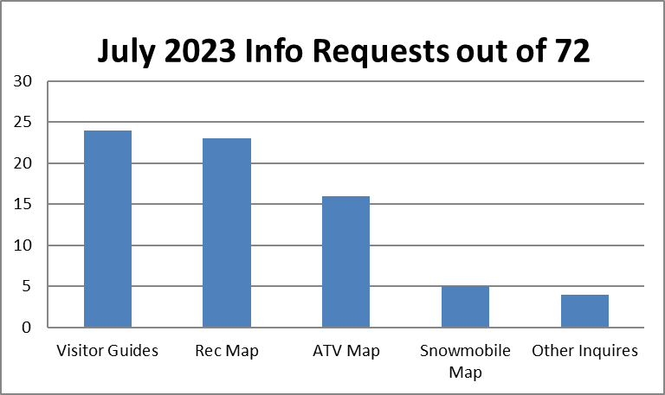
- Distributed: 2,345 of the 2023 Langlade County Visitor Guide have been distributed from the Economic Development Corporation Office since January 23, 2023.
- Facebook: 13,935 “Followers” The top post in July was the announcement of Perch Lake Campground flyer. This post reached 9,090 people with 997 engagements and 327 link clicks.
- Instagram: 458 “Followers” as of July 2023.
- Everbridge: There have been 1,375 people that have registered since June 1, 2016. Everbridge registration brochures and alcinfo.com business cards with Everbridge QR code was available at the Langlade County Fair.
- Northcentralwisconsin.com: This is the portal website through ITBEC and we received 7 visits to Langlade County Page in the month of July.
- alcinfo.com: 329 users in the month of July:
langladecounty.org: 2 referrals langladecountyedc.org: 1 referral
Other Tourism Information:
- Continued sending out Everbridge mass notifications and marketing Everbridge and alcinfo.com webpage.
- Everbridge sign up brochure and alcinfo.com business cards were available at the Langlade County Fair.
- Continue refining the Langlade County Tourism Information binder for staff and volunteers for answers to visitor’s questions.
- Continued Social Siren Marketing social and digital marketing campaigns.
- Travel Wisconsin’s Hiking and Biking Report are updating reports for Langlade County on a weekly basis.
- Started marketing the Antigo Historic Audio Tour on the Strive On app. Promoted on the Breakfast Club. A brochure and flyer were developed and handed out at the Langlade County Fair.
- Langlade County Tourism commercials are being promoted on WAOW Channel 9.
- Submitted ads for Up North Action Magazine August/September issue and Travel Wisconsin Winter Traveler Magazine.
- Working with Konect on Langlade County Tourism app alternative.
- Informational booth at the Langlade County Fair. There were 178 items taken.

