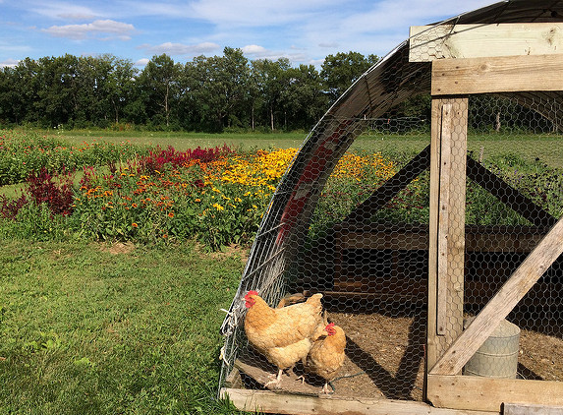
DO YOU HAVE A FOOD OR FARM BUSINESS?
ARE YOU INTERESTED IN TRYING OUT A NEW IDEA?
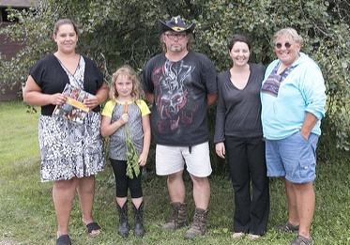
Join us for a workshop designed to help you identify which grants or other financial options might be right for you. This workshop will address ways to plan your project and strengthen your application.
Photo credit: Rob Myers, SARE

Dates & Locations

Friday, September 21st – Western WI – La Crosse County
Room 0430, La Crosse County Admin. Building, 212 6th St., North La Crosse, WI 54601
*Early-bird registration closes on Sept 14th
To register, contact: 608-785-9593 or email uwexmail@lacrossecounty.org
Para más información sobre este evento, comuníquese con Jay Lema al 608.800.6726.
Hmoob - Yog muaj lus nug thov hu rau Ariana Thao 608.800.6725.

Saturday, September 22nd – Southern WI – Iowa County
Iowa County Health and Human Services Building, Community Room, 303 W. Chapel Street, Dodgeville, WI 53533
*Early-bird registration closes on Sept 14th
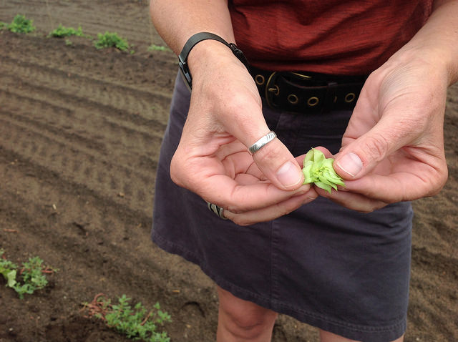
To register, contact: Barry Hottmann or Gene Schriefer at barry.hottmann@ces.uwex.edu or gene.schriefer@ces.uwex.edu or 608-930-9850.
Para más información sobre este evento, comuníquese con Jay Lema al 608.800.6726.
Hmoob - Yog muaj lus nug thov hu rau Ariana Thao 608.800.6725.

Friday, September 28th – Eastern WI – Brown County
Northeast Wisconsin Technical College, 2740 Mason St., Green Bay, WI. Enter
at the "Student Center" main door and proceed to the Eagle Event Center Room.
* Early-bird registration closes on Sept 20th
To register, contact: Liz Binversie at elizabeth.binversie@ces.uwex.edu or 920-391-4612
Para más información sobre este evento, comuníquese con Jay Lema al 608.800.6726.
Hmoob - Yog muaj lus nug thov hu rau Ariana Thao 608.800.6725.

Thursday, October 11th – North-central WI – Taylor County
USDA/County Service Center, 925 Donald St., Medford, WI 54451
* Early-bird registration closes on Oct 4th
To register, contact: Cathy Mauer, 715-748-3327 ext. 3, cathy.mauer@ces.uwex.edu
Para más información sobre este evento, comuníquese con Jay Lema al 608.800.6726.
Hmoob - Yog muaj lus nug thov hu rau Ariana Thao 608.800.6725.

REGISTRATION FEE OF $15 WILL COVER THE COST OF LUNCH AND MATERIALS
Scholarships are available to help cover the registration fee. Please ask for more information during registration.

If you are interested in attending and need accommodations, please let your local registration contact know.

Successfully Applying to Agricultural Grant Programs
2018 Workshop Agenda

This workshop is designed to give farmers and agricultural entrepreneurs information, tools, and hands-on training to strengthen grant and loan applications. This workshop will help you create a competitive application and get the financial resources you need to fuel your business.

9:00 AM Check-in

9:30 AM Welcome and Introductions
Participants are invited to give a brief introduction to their projects
Diane Mayerfeld, UW-Extension/SARE

10:00 AM Designing a sound project, identifying funding sources and grant-writing basics
Margaret Krome, Michael Fields Agricultural Institute

12:00 PM Lunch

12:30 PM Lunch Program – Perspective from a grant recipient:
“How I applied for and used a grant in my agriculture business”

1:15 PM Grant Programs Highlights
- USDA Specialty Crop Block Grant
- DATCP Buy Local, Buy Wisconsin Grants
- USDA SARE Farmer-Rancher Grant
- DATCP Farmer-Led Watershed Grants

2:00 PM Hands-on Grant Proposal Evaluation & Development
- Review and evaluate an actual proposal in groups.
Diane Mayerfeld, UW-Extension/SARE

3:00 PM Additional Financial Options
- Farm Service Agency – Farm Loans & Micro-loan Program
- Natural Resources Conservation Service – Cost Share Programs
- Farm Credit System Bank – Loan Programs

3:45 PM Networking and one-on-one Q&A with presenters

4:00 PM Adjourn

PARTNERS:
Michael Fields Agricultural Institute  USDA, Rural Development  USDA, SARE  UW-Cooperative Extension
WI Department of Agriculture, Trade and Consumer Protection   Compeer Financial

---
An EEO Affirmative Action Employer, University of Wisconsin-Extension provides equal opportunities in employment and programming, including Title IX and ADA requirements.

