2017 ANNUAL REPORT
2017 Spring Graduating 2017 Fall Graduating
Entreprenuer Class Entreprenuer Class

April’s Pooch Parlor Memories Repurposed

MOVING ANTIGO/LANGLADE COUNTY FORWARD!

THANK YOU!
LCEDC BOARD OF DIRECTORS 2017
President: Brady Koss
Vice President: Thomas Bauknecht - City of Antigo Alderman
Secretary: Carol Gottard-Feller - County Board Supervisor
Member: Bill Brandt - City of Antigo Mayor
Member: Warren Wagner
Member: Pete Pennington - County Board Vice-Chair
Member: Tom Gallenberg
Member: Andy Merry
Member: Mike Bernatz
Member: Fred Westphal
Member: Steve Wilder

LCEDC EXECUTIVE COMMITTEE 2017
President: Brady Koss
Vice President: Thomas Bauknecht - City of Antigo Alderman
Secretary: Carol Gottard-Feller - County Board Supervisor
Member: Andy Merry
Member: Fred Westphal

LOAN REVIEW BOARD 2017
Chair: Ben Zelazoski
Member: Dave Visser
Member: Gary Smits
Member: Leah Antoniewicz
Member: Rhonda Norrbom
Member: Carol Feller-Gottard
Member: Glenn Bugni

The Langlade County Economic Development Corporation’s staff would like to recognize and thank our board members for all they do to keep Langlade County and the City of Antigo moving forward.

THANK YOU!
The Langlade County Economic Development Corporation would like to thank our 2017 contributors for believing in our mission to keep moving Langlade County and the City of Antigo forward.
LANGLADE COUNTY
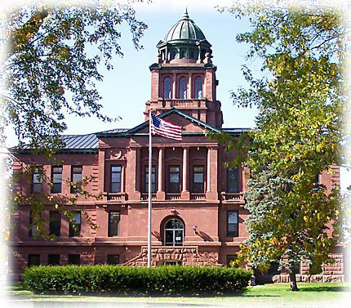
CITY OF ANTIGO
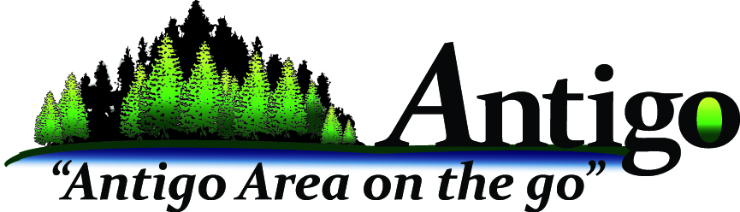
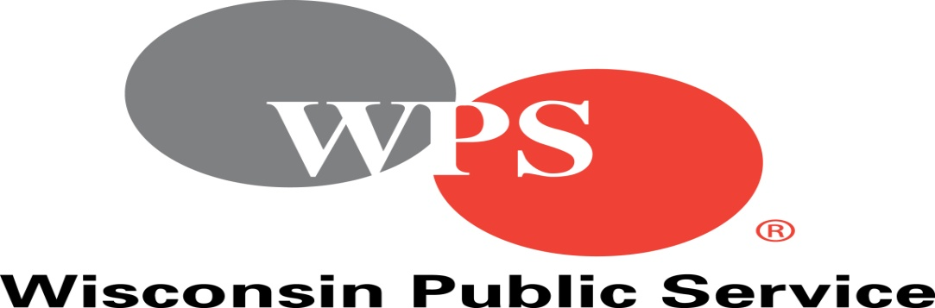

DATA INFORMATION
- SALES TAX CONTINUES TO RISE WITH A $12,588.28 INCREASE FROM 2016
(Total $1,658,021.88)
SALES TAX 2017 Sales Tax 2016  2017 vs 2016  MONTH AMOUNT MONTH AMOUNT  January $ 103,519.93 -$33,095.27 January $ 136,615.20  February $ 152,320.50 $58,502.63 February $ 93,817.87  March $ 115,907.02 $20,298.57 March $ 95,608.45  April $ 92,406.67 -$82,040.36 April $ 174,447.03  May $ 126,841.90 $32,796.04 May $ 94,045.86  June $ 155,899.68 -$14,747.68 June $ 170,647.36  July $ 136,572.44 -$4,851.56 July $ 141,424.00  August $ 170,465.30 $25,246.44 August $ 145,218.86  September $ 161,777.89 -$2,614.47 September $ 164,392.36  October $ 130,367.00 -$5,133.27 October $ 135,500.27  November $ 159,488.69 $19,997.75 November $ 139,490.94  December $ 152,454.86 -$1,770.54 December $ 154,225.40  Total $ 1,658,021.88 $12,588.28 Total $ 1,645,433.60 |  | Sales Tax 2015

ECONOMIC DEVELOPMENT REVOLVING LOAN FUND (EDRLF) 2017
- Total Balance Available to Loan $517,682
COMMUNITY DEVELOPMENT FUND 2017
- Total Balance Available to Loan $86,104

Revolving Loan Fund Portfolio as of 12/31/2017
20 business loan portfolio = $2,417,500 borrowed
$1,173,931 owed
$7,287,500 leveraged
110 jobs created
404.7 employed
Three (3) loans paid in full
One (1) new loan total amount $75,000
Community Development Fund as of 12/31/2017
1 business loan portfolio - $120,000 borrowed
$96,563 owed: 12 jobs retained; 2 job created
EDC Activities Report
--Economic Development Corporation Business Website: 7,812 Visits; with 81% new visitors in 2017.
Top referral sites: Alcinfo.com Main Keyword Searched: Langlade County Economic Development Corp
--Facebook: 229 “Likes” The top post reached 5,338 people. The post was about congratulating Brent and Jackie Hipke for purchasing the Wild Wolf Inn. The post had 261 reactions, comments and shares with 1,084 post clicks.
-- Tools for Business: We received 30 visits to Langlade County EDC Page in 2017.
-- alcinfo.com: We received 234 referral visits to Langlade County EDC website in 2017.

2017 Measurements
- Worked with Fullers Sales and Service to purchase building and retain 6 jobs
- Awarded one (1) Downtown Entrepreneurs Grant
- Created a Langlade County Broadband Committee
- Continue to focus on our Logging/Forestry Industry through Education Partners and Economic Development Partners
- Locate in Wisconsin; inventory of land and vacant or turn-key commercial properties; 62
- Created Antigo/Langlade County Workforce Development Taskforce; Collaboration on bringing best practices in talent attraction and development to our businesses and future workers in Langlade County
- Facilitated workshops for area businesses on talent attraction and retention strategies
- Graduated 6 students from the Entrepreneurs Program
- Hosted Three Business Essential Courses: Bookkeeping 101, QuickBooks, Financials
- Allowed space in LCEDC Conference Room for State and Federal Agencies for Workforce Training and Development Purposes
- Allowed space in LCEDC Conference Room for Small Business Development Center and Wisconsin Women In Business Corporation for Business Resources
- Continue to educate the community on Economic Development Corporation roles and activities by speaking and attending different committee and organization meetings and events
- Continue to administer and monitor Langlade County Revolving Loan Fund, Langlade County Community Development Fund, City of Antigo Public Improvement Fund, City of Antigo CDBG and PFED, TEA Grant Programs
- Collaborate with Langlade County Forestry Department and City of Antigo Park and Recreation Department to market Langlade County Recreational Opportunities for tourism
- Collaborated with City of Antigo Park and Recreation Department and Antigo/Langlade County in a City of Antigo Destination Assessment
TOURISM DEVELOPMENT
TOURISM DIRECT SPENDING IN LANGLADE COUNTY WAS 47.7 MILLION DOLLARS IN 2017.
-- Tourism Website: 21,357 visits, with 67.22% new visitors in 2017:
Top referral site: co.langlade.wi.us Main Keyword Searched: Langlade County snowmobile trails
-- App Downloads: 259 downloaded in 2017 total downloads since launch: 2,254
-- Recreation Information Requests: 654 Recreation Requests in 2017;
Top Request: Other Inquires

-- Distributed: 3,239 2017 Recreation Maps from the Economic Development Corporation Office since January 2017
-- Facebook: 10,754 “Likes.” The top post was about the ATV trails will be opening on May 1st at 7 am. This post reached 10,685 people with 291 reactions, comments & shares and 605 post clicks.
-- Travelwisconsin.com: We received 660 visits to Langlade County Page in 2017
-- Northcentralwisconsin.com: This is the portal website through ITBEC and we received 220 visits to Langlade County Page in 2017
-- Langladecountyedc.org: We received 67 visits to Langlade County Page in 2017
-- Discoverwisconsin.com: We received 78 visits to Langlade County Page in 2017
-- Lake-link.com: We received 55 visits to Langlade County Page in 2017
-- Atvtracks.com: We received 27 visits to Langlade County Page in 2017
-- Snowtracks.com: We received 17 visits to Langlade County Page in 2017
-- Alcinfo.com: We received 199 visits to Langlade County Page in 2017
-- Attended Green Bay RV & Camping Show, Chicago Travel Adventure Show, and Milwaukee Journal Sentinel Sports Show
WORKS IN PROGRESS

- Continue to build a partnership with Antigo/Langlade County Chamber of Commerce to enhance services for the betterment of the community

- Working with a business consultant to create a more aligned LCEDC Strategic Plan

- Working with the City, County and Wisconsin Economic Development Corporation to assist on strategies on repurposing buildings that are off the tax roll

- Continue to put our Wood Products Industry in the forefront to show what significant economic impact it is for this region

- Working with like counties on the possible resurrection of past programs as well as other recommendations to aide in development in our more rural counties

- Continue to establish relationships with local legislators regarding rural counties challenges

- Continue to work with Wisconsin Economic Development Corporation along with Department of Administration on the future of the Economic Development Revolving Loan Fund

- Continue to work with our education partners regarding workforce efforts, entrepreneurial programming and manufacturers council

- Continue to survey local businesses to help achieve their needs to continue to grow and prosper here in Langlade County

- Continue to search other funding resources for capacity building of the Corporation

- Continue to take continue education courses and attend conferences to enhance the corporation

- Continue to work with partners on enhancing community resources: community calendar creation, alcinfo.com, everbridge notifications, destination assessment, and 211 United Way

LANGLADE COUNTY APPOINTED BOARDS/COMMITTEES
- INTERNATIONAL TRADE BUSINESS ECONOMIC TOURISM COMMITTEE (ITBEC)
- LANGLADE COUNTY FAIRGROUNDS PROMOTIONAL COMMITTEE
- NORTHWOOD’S RAIL TRANSIT COMMISSION BOARD
- LANGLADE COUNTY WOOD AD HOC COMMITTEE
- NORTHCENTRAL WISCONSIN WORKFORCE DEVELOPMENT BOARD
GOVERNOR APPOINTED
- NORTHCENTRAL WISCONSIN REGIONAL PLANNING COMMISSION
REGIONAL ECONOMIC DEVELOPMENT
- GROW NORTH REGIONAL ECONOMIC DEVELOPMENT BOARD
- NORTH CENTRAL WISCONSIN DEVELOPMENT COPORATION
- LANGLADE COUNTY INTERGOVERMENTAL TASKFORCE
ADVISORY COMMITTEES/TASKFORCES
- LANGLADE COUNTY MANUFACTURING COUNCIL
- ADVISORY COMMITTEE FOR NTC DAY NORTH CENTRAL TECHNICAL COLLEGE
- ANTIGO FIRST
- ANTIGO/LANGLADE COUNTY COLLABORATIVE COMMITTEE
- FORWARD SERVICES STEERING COMMITTEE
- WOMENS BUSINESS INIATIVES CORPORATION NORTHERN WISCONSIN ADVISORY COMMITTEE
- ANTIGO FAB LAB STEERING COMMITTEE/ANTIGO PRIDE
- ANTIGO/LANGLADE COUNTY WORFORCE DEVELOPMENT TASKFORCE
- UNIFITED SCHOOL DISTRICT OF ANTIGO CAREER PLANNINGCOMMITTEE
- UNIFITED SCHOOL DISTRICT OF ANTIGO FORESTRY COMMITTEE
- CITY OF ANTIGO DESTINATION TASKFORCE
SUMMARY
AS THE LANGLADE COUNTY ECONOMIC DEVELOPMENT CORPORATION CONTINUES TO GROW, WE RELY HEAVILY ON THE SUPPORT FROM OUR BUSINESS COMMUNITY, COMMUNITY ORGANIZATIONS AND MUNICIPALITIES.

WE ARE A VERY VITAL AND A MUCH NEEDED PART OF THIS COMMUNITY AND ACT AS A RESOURCE AND FACILITATOR FOR NUMEROUS ENTITIES, BUSINESSES AND INDIVIDUALS.

WE HAVE STARTED MANY COLLABORATIVE EFFORTS AND ARE PROUD OF OUR ACCOMPLISHMENTS. WE ARE EXCITED TO CONTINUE TO MOVE LANGLADE COUNTY AND THE CITY OF ANTIGO FORWARD!

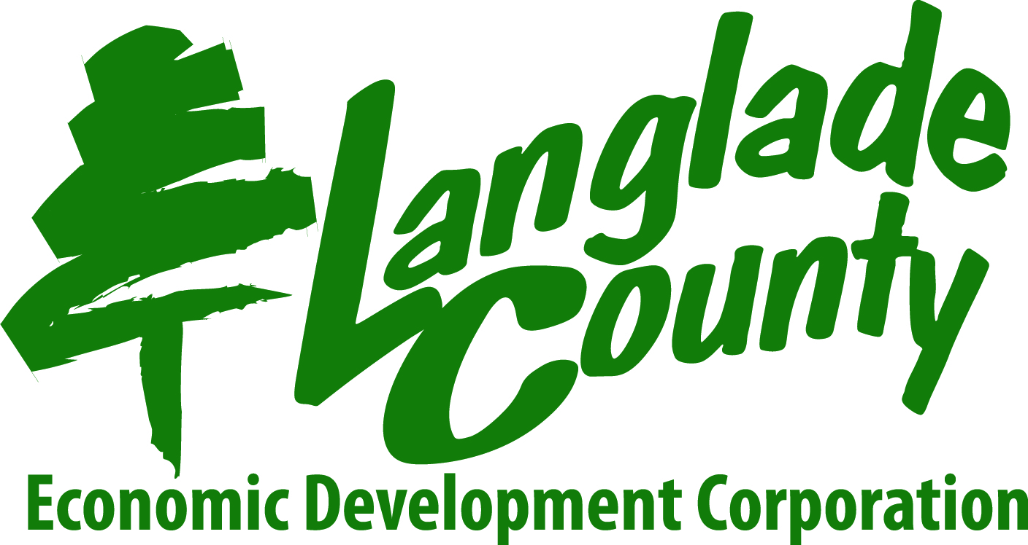

EDC STAFF
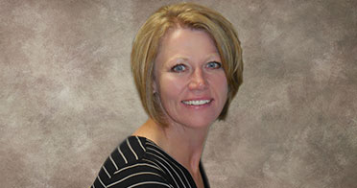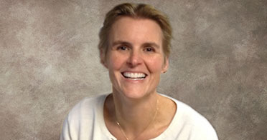
ANGIE CLOSE - EXECUTIVE DIRECTOR KERI BECK – OPERATIONS MANAGER

