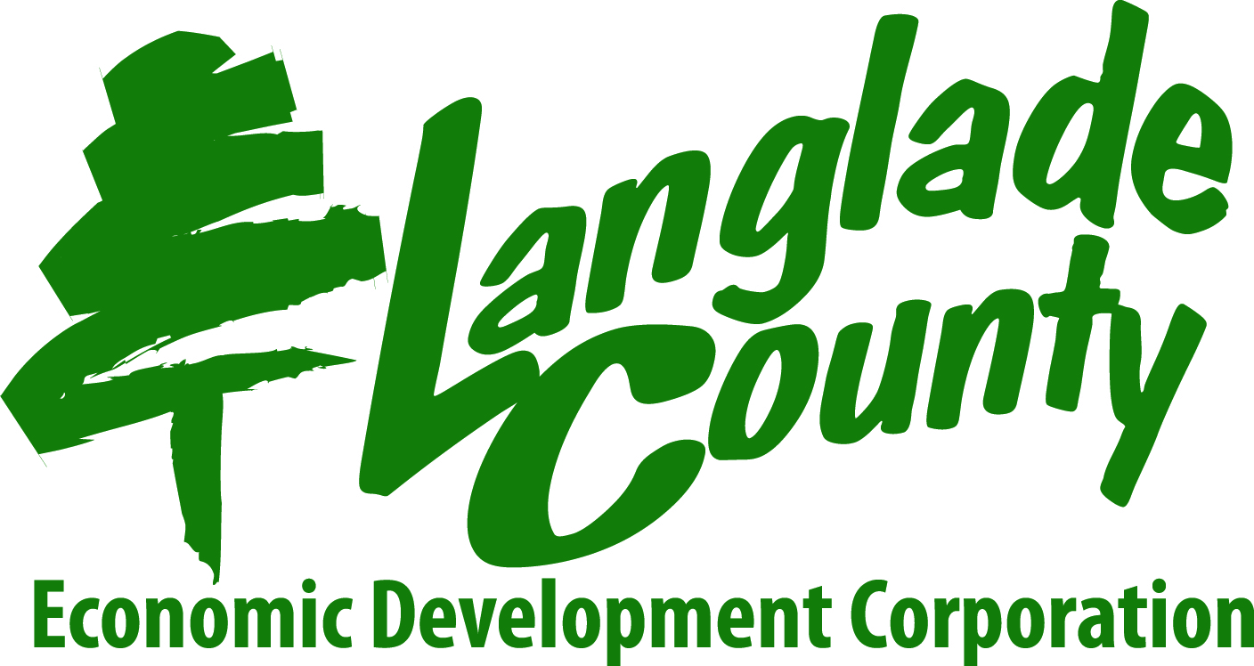

**ENTREPRENEURSHIP TRAINING COURSE**

**Class Location: Langlade County Economic Development Corporation**

**312 Forrest Avenue**

**Antigo, WI 54409**

**Class Dates: Thursdays, September 17th to November 12th**

**Class Times: 5:30 – 8:30 p.m.**

**Registration: 715.623.5123 ~ aclose@co.langlade.wi.us**

**Class Fee: $275.00 ($250.00 scholarships available upon successful completion)**

**Workbook Fee: $50.00 (non-refundable)**

**Registration is limited to 20 students.**

To learn more about the **Entrepreneurship Training Course**, plan to attend one of the free **Exploring Entrepreneurship Workshops** scheduled in August:

**Monday, August 24 @ 5:30pm Elcho Town Hall N11234 Dorr Street, Elcho   
Tuesday, August 25 @ 5:30 pm White Lake Community Center 615 School Street, White Lake   
Thursday, August 27 @ 5:30 pm LCEDC Office-312 Forrest Ave. -WT112-Antigo**

There is no cost to attend an **Exploring Entrepreneurship** workshop, but pre-registration is required. To register, visit www.langladecountyedc.org/events, call Langlade County Economic Development at 715.623.5123 or email [aclose@co.langlade.wi.us](mailto:aclose@co.langlade.wi.us) .

***Made possible by The Suick Family Foundation!!***