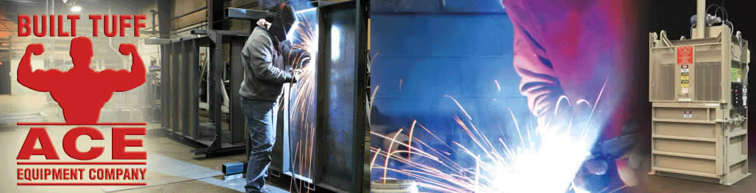

Receptionist

Ace Equipment Company is seeking a full-time candidate who is detail oriented, organized and independent. Duties include: answering phone, some A/P, light cleaning and manufacturing of parts. Benefits include health insurance, retirement plan, paid vacation and holidays. Candidate should be proficient with Word, Excel, and QuickBooks and have good interpersonal skills. For more information or to apply, contact:
Ace Equipment Company
W9112 Cherry Road,
Antigo, WI 54409
(715) 627-2400

