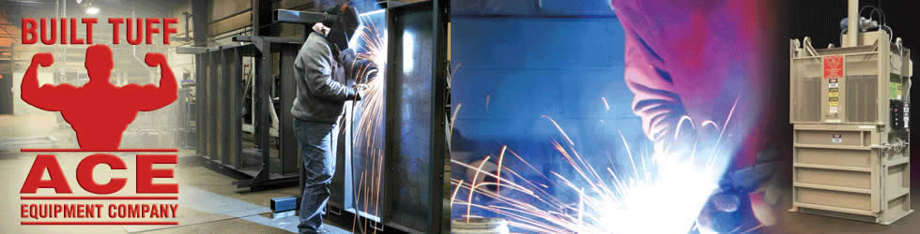

Engineer/Drafter
Ace Equipment Company is seeing the right candidate to assist with product sales drawings. Hours are full time, compensation is based on experience, benefits are available. Experience with Auto Cad is preferred. Must be familiar with drafting techniques, must have a mechanical aptitude, be able to complete basic math calculations, good communication skills, detailed orientated basic welding, electrical and hydraulic experience. Duties include developing of sales drawing using CAD, sketch layouts of machines and compute angles, weights, surface areas, dimensions, tolerances, leverages and location of holes. Positions inquiries should be made to:
Ace Equipment Company
W9112 Cherry Road,
Antigo, WI 54409
(715) 627-2400

